**HTML:**

HTML-Hypertext Markup Language

1. HTML is one of the core language for any websites.

2. HTML is used for structuring of website.

3. This is a static programming language.

HTML stands for Hyper Text Markup Language, which is the most widely used language on Web to develop web pages. HTML was created by Berners-Lee in late 1991 but "HTML 2.0" was the first standard HTML specification which was published in 1995. HTML 4.01 was a major version of HTML and it was published in late 1999. Though HTML 4.01 version is widely used but currently we are having HTML-5 version which is an extension to HTML 4.01, and this version was published in 2012.

**Structure of HTML Document:**

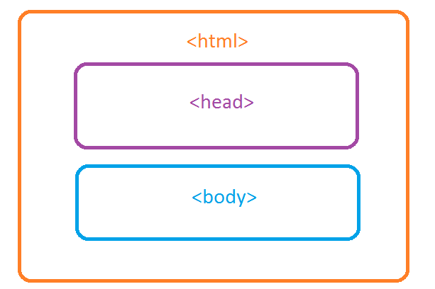

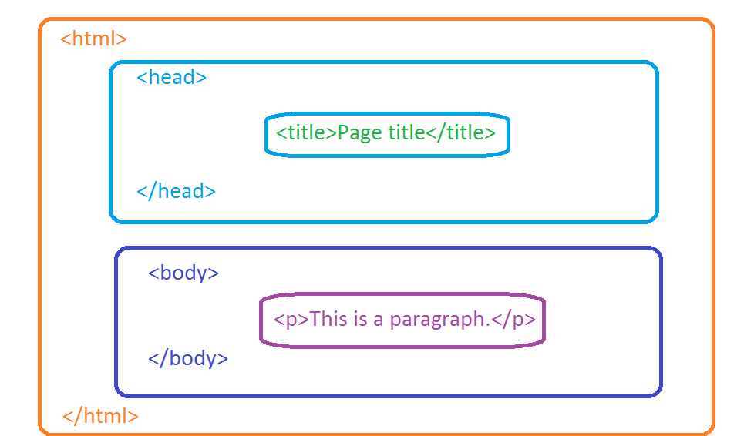

**Rules of Writing HTML Documents:**

1. Syntax:

<tagname>content goes here </tagname>

1. Always use lowercase letters for html tag names.
2. Always add end tag </>(if required)

Example:

1. <p></p>
2. <br>
3. <hr>

**HTML Elements (or) Tags:**

1. HTML elements comes with start tag and end tag
2. Any content should be between HTML Tags only.

Example:

<h1>Welcome to HTML</h1>

**The <!DOCTYPE> Declaration:**

The <!DOCTYPE> declaration represents the document type, and helps browsers to display web pages correctly.

It must only appear once, at the top of the page (before any HTML tags).

The <!DOCTYPE> declaration is not case sensitive.

The <!DOCTYPE> declaration for HTML5 is:

<!DOCTYPE html>

# <html> Tag:

* The <html> tag tells the browser that this is an HTML document.
* The <html> tag represents the root of an HTML document.
* The <html> tag is the container for all other HTML elements (except for the[<!DOCTYPE>](https://www.w3schools.com/tags/tag_doctype.asp) tag).

## <head> Element:

1. The <head> element is a container for metadata (data about data) and is placed between the <html> tag and the <body> tag.
2. HTML metadata is data about the HTML document. Metadata is not displayed.
3. Metadata typically define the document title, character set, styles, links, scripts, and other meta information.
4. The following tags describe metadata: <title>, <style>, <meta>, <link>, <script>, and <base>.

## <title> Element:

The <title> element defines the title of the document, and is required in all HTML/XHTML documents.

The <title> element:

* defines a title in the browser tab
* provides a title for the page when it is added to favorites
* displays a title for the page in search engine results

### Example:

<!DOCTYPE html>  
<html>  
<head>  
  <title>Page Title</title>  
</head>  
<body>  
The content of the document......  
</body>  
</html>

## <style> Element:

The <style> element is used to define style information for a single HTML page

### Example:

<style>  
  body {background-color: powderblue;}  
  h1 {color: red;}  
  p {color: blue;}  
</style>

## <link> Element:

The <link> element is used to link to external style sheets:

### Example:

<link rel="stylesheet" href="mystyle.css">

## <meta> Element:

The <meta> element is used to specify which character set is used, page description, keywords, author, and other metadata.

Metadata is used by browsers (how to display content), by search engines (keywords), and other web services.

Define the character set used:

<meta charset="UTF-8">

Define a description of your web page:

<meta name="description" content="Free Web tutorials">

Define keywords for search engines:

<meta name="keywords" content="HTML, CSS, XML, JavaScript">

Define the author of a page:

<meta name="author" content="John Doe">

Refresh document every 30 seconds:

<meta http-equiv="refresh" content="30">

Example:

<meta charset="UTF-8">  
<meta name="description" content="Free Web tutorials">  
<meta name="keywords" content="HTML,CSS,XML,JavaScript">  
<meta name="author" content="John Doe">

## <script> Element:

The <script> element is used to define client-side JavaScripts.

This JavaScript writes "Hello JavaScript!" into an HTML element with id="demo":

Example:

<script>  
function myFunction {  
  document.getElementById("demo").innerHTML = "Hello JavaScript!";  
}  
</script>

## <base> Element:

The <base> element specifies the base URL and base target for all relative URLs in a page:

Example:

<base href="https://www.w3schools.com/images/" target="_blank">

## HTML head Elements:

|  |  |
| --- | --- |
| **Tag** | **Description** |
| [<head>](https://www.w3schools.com/tags/tag_head.asp) | Defines information about the document |
| [<title>](https://www.w3schools.com/tags/tag_title.asp) | Defines the title of a document |
| [<base>](https://www.w3schools.com/tags/tag_base.asp) | Defines a default address or a default target for all links on a page |
| [<link>](https://www.w3schools.com/tags/tag_link.asp) | Defines the relationship between a document and an external resource |
| [<meta>](https://www.w3schools.com/tags/tag_meta.asp) | Defines metadata about an HTML document |
| [<script>](https://www.w3schools.com/tags/tag_script.asp) | Defines a client-side script |
| [<style>](https://www.w3schools.com/tags/tag_style.asp) | Defines style information for a document |

**<body> Tag:**

* The <body> tag defines the document's body.
* The <body> element contains all the contents of an HTML document, such as text, hyperlinks, images, tables, lists, etc.

**HTML Attributes:**

1. All HTML elements can have **attributes**
2. Attributes provide **additional information** about an element
3. Attributes are always specified in **the start tag**
4. Attributes usually come in name/value pairs like: **name="value"**

|  |  |
| --- | --- |
| **Attribute** | **Description** |
| alt | Specifies an alternative text for an image, when the image cannot be displayed |
| disabled | Specifies that an input element should be disabled |
| href | Specifies the URL (web address) for a link |
| id | Specifies a unique id for an element |
| src | Specifies the URL (web address) for an image |
| style | Specifies an inline CSS style for an element |
| title | Specifies extra information about an element (displayed as a tool tip) |

and more…………..

Examples:

<img src=”image1.jpg”>

## Style Attribute:

Setting the style of an HTML element, can be done with the style attribute.

The HTML style attribute has the following **syntax**:

<tagname style="property:value;">

The ***property*** is a CSS property. The ***value*** is a CSS value.

There are 3 ways of implementing style in HTML :

1. **Inline Style**: In this method, the style attribute is used inside the HTML start tag.
2. **Embedded Style**: In this method, the style element is used inside the <head> element of the document.
3. **External Style Sheet**: In this method the <link> element is used to point to an external CSS file.

### Inline Style:

In Inline styling, the CSS rules are directly written inside the starting tag using the style attribute. The style attribute includes a series of CSS property and value pairs. Each ‘ **property : value** ‘ pair is separated by a semicolon ( ; ).

### Embedded Style:

Embedded or internal style sheets only affect the document they are embedded in. Embedded style sheets are defined in the <head> section of an HTML document using the <style> tag.

### External Style Sheet:

External Style Sheets method can be useful when the CSS has to be applied to various web pages. An external style sheet holds all the style rules in a separate document that you can link from an HTML file on your site.  
There are two ways of attaching external style sheets –

* **Linking External Style Sheets**:   
  In this method, an external style sheet is linked to an HTML document using the <link> tag.
* **Importing External Style Sheets:**   
  External style sheets can be loaded into an HTML document using “@import”. The “@import” statement instructs the browser to load the CSS file. Other CSS rules can also be included using the <style> element.
* Use the style attribute for styling HTML elements
* Use background-color for background color
* Use color for text colors
* Use font-family for text fonts
* Use font-size for text sizes
* Use text-align for text alignment